**Project Report**

Captcha Generator System

|  |  |
| --- | --- |
|  | **Name & Surname** |
|  | **Beyza Belen İrican** |
|  | **Müslüm Sivri** |

**TABLE OF CONTENTS**

**1 INTRODUCTION** 4

1.1 PROJECT DESCRIPTION 4

**2 ENTITY RELATIONAL MODEL** 5

2.1 ENHANCED ER DIAGRAM 5

2.2 RELATIONAL SCHEMA & MAPPING 6

**3 NORMALIZATION** 7

3.1 FUNCTIONAL DEPENDENCIES 7

3.2 UNNORMALISED FORM 7

3.3 FIRST NORMAL FORM 7

3.4 SECOND NORMAL FORM 7

3.5 THIRD NORMAL FORM 7

**LIST OF FIGURES**

Figure 1: EER diagram of the Captcha Generator System Database ............................... 5

Figure 2: Relational schema of the Captcha Generator System Database with arrows indicating referential integrity....................................................................................................... 6

# INTRODUCTION

## PROJECT DESCRIPTION

The Captcha Generator System Database stores information about the verification, authorization, user, image,userimage, imagerecod, math, usermath, mathrecord,text, usertext, textrecord, background, sound, usersound, soundrecord of a system.Database has four types(image, math, text and sound).The following data have been identified in the requirements collection and analysis phase and they are to be represented in the enterprise:

• Verification has a unique verification_id, and a code that verified the user. The Captcha Generator System is verified into verification.

• Authorization has a unique authorization_id, system_log_no, last_login_date, current_login_date, user_id(foreign key references to Users table).This entity is used for keeping track of users' log history.

• Users has a unique user_id, name, lastName, email, control_captcha(checking of captcha validation), activate(checking of verification validation).This entity is used for keeping users’ information.

• Images have a unique image_id, image_type, image_path (multivalue, there are 9 different types of paths), correct_image_no (multivalue).

• UserImage has unique user_image_id, image_id(foreign key references to Images table), user_id(foreign key references to Users table), selected_image_no(multivalue, user must select 3 images).

• ImageRecord has a unique image_record_id, trial_no(number of trials), refresh_times(number of captchas that will be sent to user), userimage_id(foreign key references to UserImage table).

• Math has a unique math_id, first_operand, second_operand, operation, result(its not suitable for 3NF so, its removed).

• UserMath has a unique user_math_id, user_result, math_id(foreign key references to Math table), user_id(foreign key references to Users table).

• MathRecord has a unique math_record_id, trial_no, refresh_times, user_math_id.

• Sound has a unique sound_id, sound_sec(time length of the sound), sound_word(users should hear), sound_type(such as magic, robotic…), sound_language(multivalue, it has 4 languages).

• UserSound has a unique user_sound_id, user_language, user_word( word that user enters what s/he hears), sound_id(foreign key references to Sound table), user_id(foreign key references to Users table).

• SoundRecord has a unique sound_record_id, trial_no, refresh_times, user_sound_id(foreign key references to UserSound table).

• Texts has a unique text_id, word, word_length(removed), font_family, text_height, text_width, char_space(spaces between characters), bg_id(foreign key references to Background table), color(multivalue, it has 4 types).

• Background has a unique bg_id, bg_image_path(background image), opacity.

•  UserText has a unique user_text_id, user_input, text_id(foreign key references to Texts table), user_id(foreign key references to Users table).

• TextRecord has a unique text_record_id, trial_no, refresh_times, user_text_id(foreign key references to UserText table).

# ENTITY RELATIONAL MODEL

## ENHANCED ER DIAGRAM

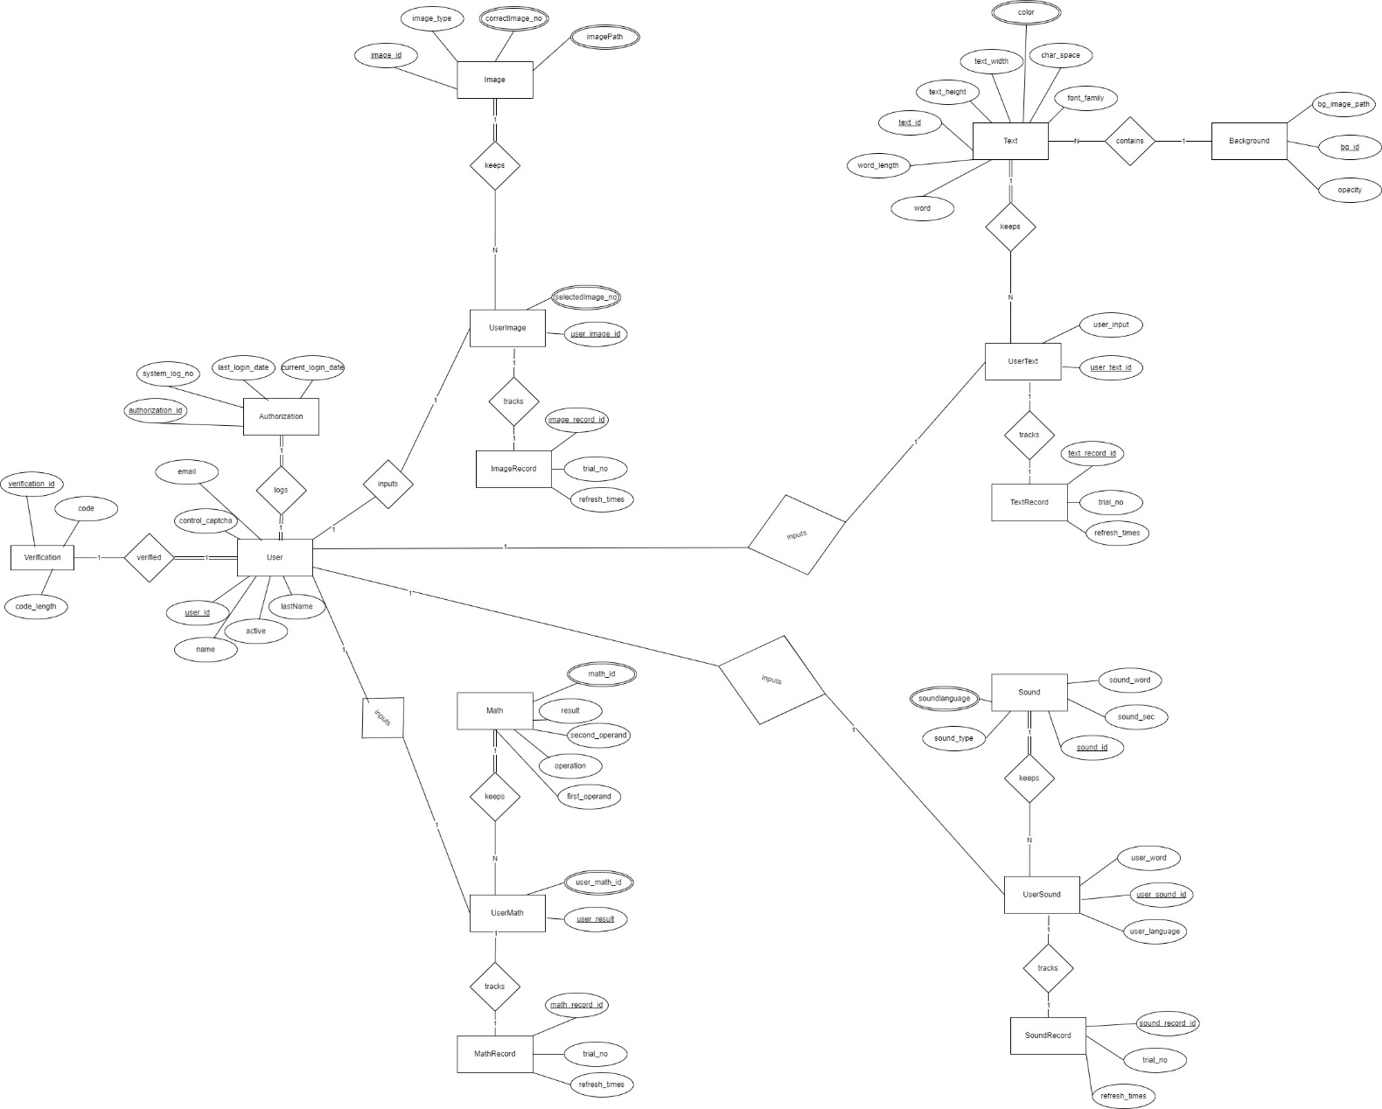

**Figure 1:** EER diagram of the Captcha Generator System Database

## RELATIONAL SCHEMA & MAPPING

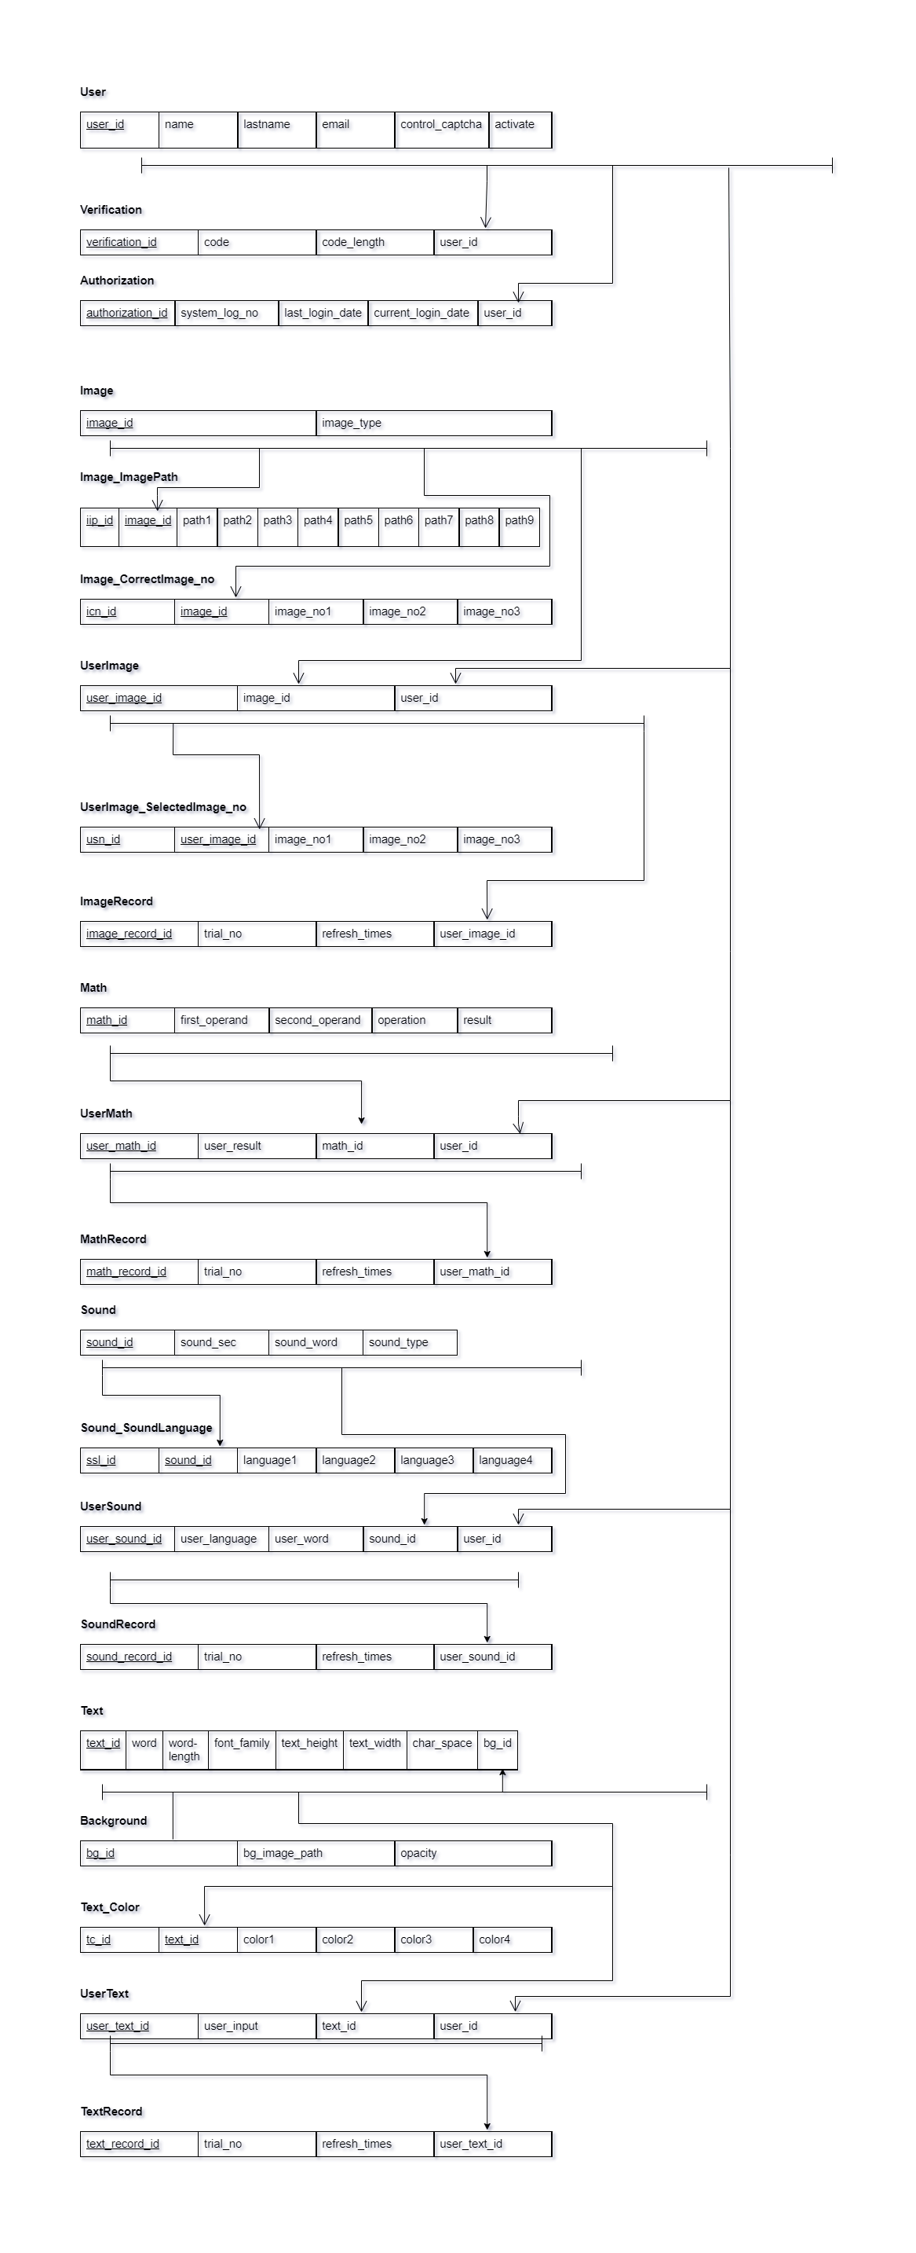

**Figure 2:** Relational schema of the Captcha Generator System Database with arrows indicating referential integrity

# NORMALIZATION

## FUNCTIONAL DEPENDENCIES

(The following is the set of functional dependencies (FD's) of COMPANY.)

F = { FD1: user_id→ name, lastName, email , control_captcha, activate

FD2: verification_id→code, code_length, user_id

FD3: authorization_id →system_log_no, last_login_date, current_login_date, user_id

FD4:image_id → image_type, correct_image_no, image_path

FD5: user_image_id→image_id, user_id, selected_image_no

FD6: image_record_id→trial_no, refresh_times, user_image_id

FD7: math_id→ first_operand, second_operand, operation, result

FD8: user_math_id → user_result, math_id, user_id

FD9: math_record_id→ trial_no, refresh_times, user_math_id

FD10: sound_id→ sound_sec, soud_word, sound_type, sound_language

FD11: user_sorund_id → user_language, user_word, user_id, sound_id

FD12: sound_record_id→ trial_no, refresh_times, user_sound_id

FD13: text_id→ word, word_length, font_family, text_height, text_width, char_space, bg_id, color

FD14: bg_id → bg_image_path, opacity

FD15: user_text_id → user_input, text_id, user_id

FD16: text_record_id→ trial_no, refresh_times, user_text_id }

## UNNORMALISED FORM

**User**

|  |  |  |  |  |  |
| --- | --- | --- | --- | --- | --- |
| user_id | name | lastname | email | control_captcha | activate |

**Verification**

|  |  |  |  |
| --- | --- | --- | --- |
| verification_id | code | code_length | user_id |

**Authorization**

|  |  |  |  |  |
| --- | --- | --- | --- | --- |
| authorization_id | system_log_no | last_login_date | current_login_date | user_id |

**Image**

|  |  |  |  |
| --- | --- | --- | --- |
| image_id | image_type | correct_image_no | image_path |

**UserImage**

|  |  |  |  |
| --- | --- | --- | --- |
| user_image_id | image_id | user_id | selected_image_no |

**ImageRecord**

|  |  |  |  |
| --- | --- | --- | --- |
| image_record_id | trial_no | refresh_times | user_image_id |

**Math**

|  |  |  |  |  |
| --- | --- | --- | --- | --- |
| math_id | first_operand | second_operand | operation | result |

**UserMath**

|  |  |  |  |
| --- | --- | --- | --- |
| user_math_id | user_result | math_id | user_id |

**MathRecord**

|  |  |  |  |
| --- | --- | --- | --- |
| math_record_id | trial_no | refresh_times | user_math_id |

**Sound**

|  |  |  |  |  |
| --- | --- | --- | --- | --- |
| sound_id | sound_sec | sound_word | sound_type | sound_language |

**UserSound**

|  |  |  |  |  |
| --- | --- | --- | --- | --- |
| user_sound_id | user_language | user_word | sound_id | user_id |

**SoundRecord**

|  |  |  |  |
| --- | --- | --- | --- |
| sound_record_id | trial_no | refresh_times | user_sound_id |

**Text**

|  |  |  |  |  |  |  |  |  |
| --- | --- | --- | --- | --- | --- | --- | --- | --- |
| text_id | word | word-length | font_family | text_height | text_width | char_space | bg_id | color |

**Background**

|  |  |  |
| --- | --- | --- |
| bg_id | bg_image_path | opacity |

**UserText**

|  |  |  |  |
| --- | --- | --- | --- |
| user_text_id | user_input | text_id | user_id |

**TextRecord**

|  |  |  |  |
| --- | --- | --- | --- |
| text_record_id | trial_no | refresh_times | user_text_id |

## FIRST NORMAL FORM

**User**

|  |  |  |  |  |  |
| --- | --- | --- | --- | --- | --- |
| user_id | name | lastname | email | control_captcha | activate |

**Verification**

|  |  |  |  |
| --- | --- | --- | --- |
| verification_id | code | code_length | user_id |

**Authorization**

|  |  |  |  |  |
| --- | --- | --- | --- | --- |
| authorization_id | system_log_no | last_login_date | current_login_date | user_id |

**Image**

|  |  |
| --- | --- |
| image_id | image_type |

**Image_ImagePath**

|  |  |  |  |  |  |  |  |  |  |  |
| --- | --- | --- | --- | --- | --- | --- | --- | --- | --- | --- |
| iip_id | image_id | path1 | path2 | path3 | path4 | path5 | path6 | path7 | path8 | path9 |

**Image_CorrectImage_no**

|  |  |  |  |  |
| --- | --- | --- | --- | --- |
| icn_id | image_id | image_no1 | image_no2 | image_no3 |

**UserImage**

|  |  |  |
| --- | --- | --- |
| user_image_id | image_id | user_id |

**UserImage_SelectedImage_no**

|  |  |  |  |  |
| --- | --- | --- | --- | --- |
| usn_id | user_image_id | image_no1 | image_no2 | image_no3 |

**ImageRecord**

|  |  |  |  |
| --- | --- | --- | --- |
| image_record_id | trial_no | refresh_times | user_image_id |

**Math**

|  |  |  |  |  |
| --- | --- | --- | --- | --- |
| math_id | first_operand | second_operand | operation | result |

**UserMath**

|  |  |  |  |
| --- | --- | --- | --- |
| user_math_id | user_result | math_id | user_id |

**MathRecord**

|  |  |  |  |
| --- | --- | --- | --- |
| math_record_id | trial_no | refresh_times | user_math_id |

**Sound**

|  |  |  |  |
| --- | --- | --- | --- |
| sound_id | sound_sec | sound_word | sound_type |

**Sound_SoundLanguage**

|  |  |  |  |  |  |
| --- | --- | --- | --- | --- | --- |
| ssl_id | sound_id | language1 | language2 | language3 | language4 |

**UserSound**

|  |  |  |  |  |
| --- | --- | --- | --- | --- |
| user_sound_id | user_language | user_word | sound_id | user_id |

**SoundRecord**

|  |  |  |  |
| --- | --- | --- | --- |
| sound_record_id | trial_no | refresh_times | user_sound_id |

**Text**

|  |  |  |  |  |  |  |  |
| --- | --- | --- | --- | --- | --- | --- | --- |
| text_id | word | word-length | font_family | text_height | text_width | char_space | bg_id |

**Text_Color**

|  |  |  |  |  |  |
| --- | --- | --- | --- | --- | --- |
| tc_id | text_id | color1 | color2 | color3 | color4 |

**Background**

|  |  |  |
| --- | --- | --- |
| bg_id | bg_image_path | opacity |

**UserText**

|  |  |  |  |
| --- | --- | --- | --- |
| user_text_id | user_input | text_id | user_id |

**TextRecord**

|  |  |  |  |
| --- | --- | --- | --- |
| text_record_id | trial_no | refresh_times | user_text_id |

## SECOND NORMAL FORM

**User**

|  |  |  |  |  |  |
| --- | --- | --- | --- | --- | --- |
| user_id | name | lastname | email | control_captcha | activate |

**Verification**

|  |  |  |  |
| --- | --- | --- | --- |
| verification_id | code | code_length | user_id |

**Authorization**

|  |  |  |  |  |
| --- | --- | --- | --- | --- |
| authorization_id | system_log_no | last_login_date | current_login_date | user_id |

**Image**

|  |  |
| --- | --- |
| image_id | image_type |

**Image_ImagePath**

|  |  |  |  |  |  |  |  |  |  |  |
| --- | --- | --- | --- | --- | --- | --- | --- | --- | --- | --- |
| iip_id | image_id | path1 | path2 | path3 | path4 | path5 | path6 | path7 | path8 | path9 |

**Image_CorrectImage_no**

|  |  |  |  |  |
| --- | --- | --- | --- | --- |
| icn_id | image_id | image_no1 | image_no2 | image_no3 |

**UserImage**

|  |  |  |
| --- | --- | --- |
| user_image_id | image_id | user_id |

**UserImage_SelectedImage_no**

|  |  |  |  |  |
| --- | --- | --- | --- | --- |
| usn_id | user_image_id | image_no1 | image_no2 | image_no3 |

**ImageRecord**

|  |  |  |  |
| --- | --- | --- | --- |
| image_record_id | trial_no | refresh_times | user_image_id |

**Math**

|  |  |  |  |  |
| --- | --- | --- | --- | --- |
| math_id | first_operand | second_operand | operation | result |

**UserMath**

|  |  |  |  |
| --- | --- | --- | --- |
| user_math_id | user_result | math_id | user_id |

**MathRecord**

|  |  |  |  |
| --- | --- | --- | --- |
| math_record_id | trial_no | refresh_times | user_math_id |

**Sound**

|  |  |  |  |
| --- | --- | --- | --- |
| sound_id | sound_sec | sound_word | sound_type |

**Sound_SoundLanguage**

|  |  |  |  |  |  |
| --- | --- | --- | --- | --- | --- |
| ssl_id | sound_id | language1 | language2 | language3 | language4 |

**UserSound**

|  |  |  |  |  |
| --- | --- | --- | --- | --- |
| user_sound_id | user_language | user_word | sound_id | user_id |

**SoundRecord**

|  |  |  |  |
| --- | --- | --- | --- |
| sound_record_id | trial_no | refresh_times | user_sound_id |

**Text**

|  |  |  |  |  |  |  |  |
| --- | --- | --- | --- | --- | --- | --- | --- |
| text_id | word | word-length | font_family | text_height | text_width | char_space | bg_id |

**Text_Color**

|  |  |  |  |  |  |
| --- | --- | --- | --- | --- | --- |
| tc_id | text_id | color1 | color2 | color3 | color4 |

**Background**

|  |  |  |
| --- | --- | --- |
| bg_id | bg_image_path | opacity |

**UserText**

|  |  |  |  |
| --- | --- | --- | --- |
| user_text_id | user_input | text_id | user_id |

**TextRecord**

|  |  |  |  |
| --- | --- | --- | --- |
| text_record_id | trial_no | refresh_times | user_text_id |

## THIRD NORMAL FORM

**User**

|  |  |  |  |  |  |
| --- | --- | --- | --- | --- | --- |
| user_id | name | lastname | email | control_captcha | activate |

**Verification**

|  |  |  |
| --- | --- | --- |
| verification_id | code | user_id |

**Authorization**

|  |  |  |  |  |
| --- | --- | --- | --- | --- |
| authorization_id | system_log_no | last_login_date | current_login_date | user_id |

**Image**

|  |  |
| --- | --- |
| image_id | image_type |

**Image_ImagePath**

|  |  |  |  |  |  |  |  |  |  |  |
| --- | --- | --- | --- | --- | --- | --- | --- | --- | --- | --- |
| iip_id | image_id | path1 | path2 | path3 | path4 | path5 | path6 | path7 | path8 | path9 |

**Image_CorrectImage_no**

|  |  |  |  |  |
| --- | --- | --- | --- | --- |
| icn_id | image_id | image_no1 | image_no2 | image_no3 |

**UserImage**

|  |  |  |
| --- | --- | --- |
| user_image_id | image_id | user_id |

**UserImage_SelectedImage_no**

|  |  |  |  |  |
| --- | --- | --- | --- | --- |
| usn_id | user_image_id | image_no1 | image_no2 | image_no3 |

**ImageRecord**

|  |  |  |  |
| --- | --- | --- | --- |
| image_record_id | trial_no | refresh_times | user_image_id |

**Math**

|  |  |  |  |
| --- | --- | --- | --- |
| math_id | first_operand | second_operand | operation |

**UserMath**

|  |  |  |  |
| --- | --- | --- | --- |
| user_math_id | user_result | math_id | user_id |

**MathRecord**

|  |  |  |  |
| --- | --- | --- | --- |
| math_record_id | trial_no | refresh_times | user_math_id |

**Sound**

|  |  |  |  |
| --- | --- | --- | --- |
| sound_id | sound_sec | sound_word | sound_type |

**Sound_SoundLanguage**

|  |  |  |  |  |  |
| --- | --- | --- | --- | --- | --- |
| ssl_id | sound_id | language1 | language2 | language3 | language4 |

**UserSound**

|  |  |  |  |  |
| --- | --- | --- | --- | --- |
| user_sound_id | user_language | user_word | sound_id | user_id |

**SoundRecord**

|  |  |  |  |
| --- | --- | --- | --- |
| sound_record_id | trial_no | refresh_times | user_sound_id |

**Text**

|  |  |  |  |  |  |  |
| --- | --- | --- | --- | --- | --- | --- |
| text_id | word | font_family | text_height | text_width | char_space | bg_id |

**Text_Color**

|  |  |  |  |  |  |
| --- | --- | --- | --- | --- | --- |
| tc_id | text_id | color1 | color2 | color3 | color4 |

**Background**

|  |  |  |
| --- | --- | --- |
| bg_id | bg_image_path | opacity |

**UserText**

|  |  |  |  |
| --- | --- | --- | --- |
| user_text_id | user_input | text_id | user_id |

**TextRecord**

|  |  |  |  |
| --- | --- | --- | --- |
| text_record_id | trial_no | refresh_times | user_text_id |